Design Goals and Focus Groups - Notes
- Design Goals
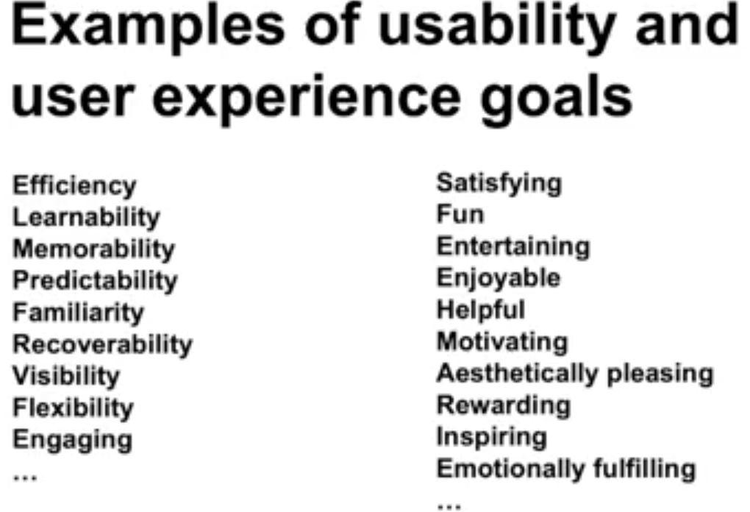
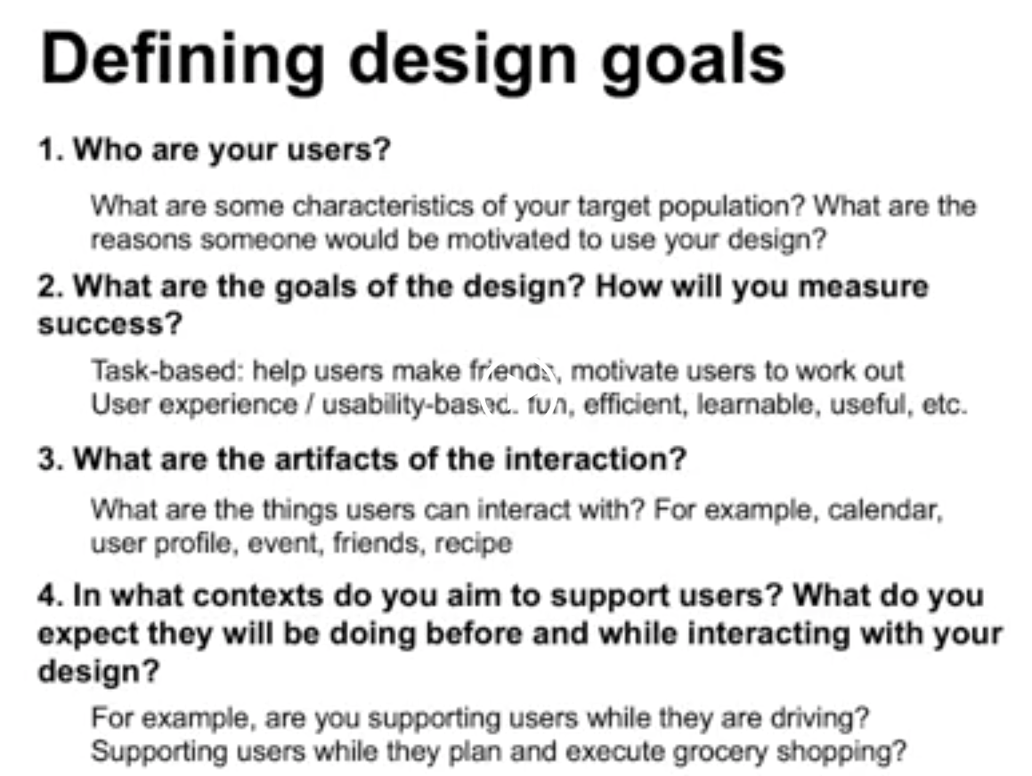
  - All designers on team have same goal
- Focus Group
  - Used is design early stage of research
  - Goal of a focus group is to get many participants in a room to gather as many different ideas and perspectives as possible
  - Ideal size is 8-10
  - Around 3-4 groups
  - Time: 60 to 90 minutes
  - When recruiting participants, send a follow-up invitation with a proposed agenda questions for discussion and time and location details
  - If topic is sensitive then inform participants ahead time so they choose whether to opt out
  - Ask permission to record, for review purposes
  - Give each participant a chance to answer each questions
  - Ensure participants have equal opportunity of input and contribution
- Interviewing
  - Asking about experience directly
  - Setup interview - decide participants
  - interview participants can be different depending on cases
  - Target users or maybe non-users
  - You may need to pay people for an interview seems to be the going rate this gets cheaper if you can have less specialized users also the amount that you'll need to pay people depends on what they believe it's going to be used for
  - if you can convey that in some way you're making the world a better place people may be willing to offer their time for free even
  - If they believe that something will be used for a profit they'll likely want a fair wage for their time
  - If you're a non-pay project and don't have enough money to really pay people, one thing that you can do is offer a token of appreciation. People often appreciate a small thoughtful gift that they can actually use like a gift certificate of some sort rather than cash.
  - Approximate if Necessary
    - If main target users unavailable then choose next related user like if doctors impossible then nurse or medical students
    - Not ideal, still better than none
  - The importance of being curious
  - What are Good questions?
  - 